**Assignment 17.1**

1. Read input and find the total number of eows

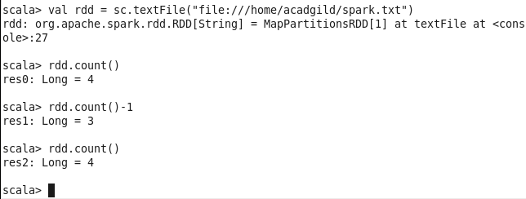

2) Total number of words in file

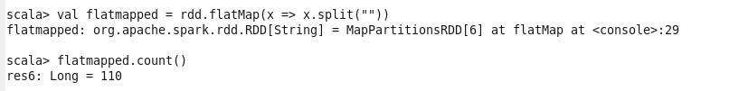

3)Find the total number of words

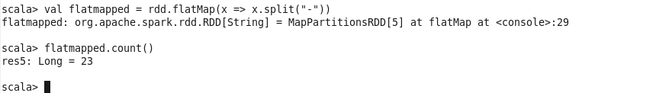

Word count

